Dental1: Dry Mouth Due to Diabetes
HISTORY
A 67-year-old male presented with the chief complaint, “My top partial denture bothers me and the teeth on my top right hurt.” The patient noticed some bleeding when brushing. He also mentioned that his mouth was feeling dry. The patient has not been to the dentist in the past three years. Medical history The patient is 5’ 6’’ tall and he weighs 185 pounds. He states that he has no allergies. The patient was diagnosed with type 2 diabetes mellitus eight years ago. At that time his HbA1c was 9.5%. He was given a course of treatment consisting of lifestyle changes (exercise and diet control) and oral medications (metformin 1,000 mg bid and glimepiride 2 mg qd). He has minimal follow-up with his primary care physician and does not see an endocrinologist. With questioning, he notes paresthesia of his feet (“It feels like I am walking on clouds”) and recently fractured his wrist with minimal trauma. The orthopedist noted bone loss on his examination and recommend a test for bone density, which has not yet been performed. His last medical visit was three months ago, revealing an HbA1c of 9.1%. His primary care physician referred him to an endocrinologist; the appointment is pending. The patient does not smoke cigarettes, and denies any history of alcohol abuse. He has not used recreational drugs for the past 20 years.
Citation: Lamster, I. B., Bittner, N., & Lorber, D. (n.d.). The patient with diabetes mellitus and xerostomia.

Dental2:Tooth Pain (pulpitis)
HISTORY
A 28 year old female patient presented with acute severe pain from the upper right side of mouth. It was poorly localized, and the patient stated that the pain radiated into the ear and the cheek on the right-hand side. Pain was spontaneous and not responding well to over-the-counter analgesics (Ibuprofen 400mg, qds), and had been gradually getting worse over the last 48 hours. The patient was experiencing sleep disturbance, and the pain came on in waves. There was extreme sensitivity to cold stimulus, but not so painful with hot stimulus.

Ent1: Presbyacusis(Hearing Loss)
HISTORY
A 75-year-old male presented with the complaints of reduced hearing in both ears associated with occasional occurrence of tinnitus, since 2 years. The patient is a known case of hypertension and is under medication. Patient had taken hearing aid 1 year back but it was of no use.

PHYSICAL EXAMINATION
On local examination of the ear [Table 1] the pinna, external auditory canal and tympanic membrane() were normal. On tuning fork test, air conduction and bone conduction were reduced, which interprets the low +^{ve} Rinne. On pure tone audiometric examination, the case was diagnosed as moderately severe sensori-neural hearing loss, with hearing threshold level in both ears between 61-80 dB hearing loss [Table 3]. The patient was unable to hear and understand even on shouting loudly. Routine hematological (hemoglobin, total count, differential count and erythrocyte sedimentation rate) investigations were done. The percentage of hemoglobin was reduced.
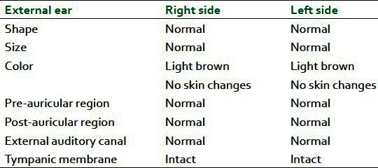Table1
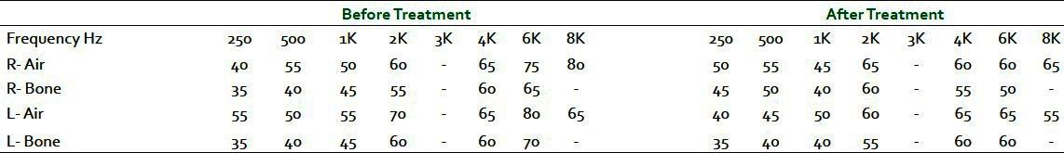Table2

Citation: Angadi, Savita S., and Vijaykumar S. Kotrannavar. “A Case Discussion on Presbyacusis.” Journal of Ayurveda and Integrative Medicine 4.1 (2013): 48–51. PMC. Web. 21 Oct. 2018.

Eye1: Glaucoma

HISTORY

The patient is a 51 year-old stay-at-home mother who presented to the center with severe right brow, right cheek and right eye pain/pressure that started 2-3 hrs prior. She also noticed blurry vision from that eye and rainbow-colored halos around lights around the same time. Accompanying symptoms include acute nausea. She has vomited twice since feeling the eye pain. Denies prior episodes. Denies flashes, floaters or diplopia. There is mild redness in the right eye.Hx myopia OU.No prior eye surgeries, trauma, amblyopia or strabismus

Ocular Medications:
None

Past Medical History:
Degenerative disc disease – lower back

Surgical History:
None

Past Family Ocular History:
Father: chronic angle closure glaucoma
No FHx of macular degeneration or other blinding diseases.

Social History:
30 pack year smoking history
Drinks alcohol on occasion
No illicit drug use

Medications:
Multivitamins
Vicodin prn (uses few days/month for back pain)

Allergies:
None

ROS:
Denies recent illnesses, new medications, CNS, lungs, GI, skin, joint problems except for above.
Citation: “Ophthalmology and Visual Sciences.” Medical College of Wisconsin, www.mcw.edu/departments/ophthalmology-eye-institute/education/ophthalmic-case-studies/ophthalmic-case-study-1.

Geri1: Dementia
HISTORY
A 78-year-old man is brought to your office by a friend who is concerned about his progressive decline in function. She reports that the patient's memory has deteriorated and that he has trouble walking,often complaining of pain in his hip. She knows that he takes medications for his pain and wonders if these medications are causing his memory problem. The patient is aware of his memory disorder and is actually concerned that he is getting "Alzheimer's disease," which his mother had, although at an older age. He focuses, however, on his "leg problem," for which he was supposed to have surgery. He is looking forward to discussing this with you because he wanted to have a "second opinion."
The friend reports that the patient still goes to work every day, but the office functions poorly because of his inability to manage the work and his confusion about existing projects. Without the patient present, she confides to you that the business is in a "shambles" and that she has noticed problems in his self-care, noting that there is often a "smell of urine." The friend is particularly concerned about his driving, but, when she mentions this, the patient becomes angry, stating, "Oh, there's nothing wrong with my driving!" She gently disagrees, stating that the patient has made serious errors on the street, on more than one occasion turning into incoming
traffic. She says, "It is only a matter Of time before there is a bad accident. I Won't drive with him anymore!"
The patient is a widower who lives alone and has no known living relatives.

PHYSICAL EXAMINATION
On physical examination, the patient walks independently using a cane. An odor of urine is noticeable. He is alert and interactive, fully cooperating with the examination and his memory is grossly intact. He shows you a list of medications (tamsulosin, donepezil, oxycodone with acetaminophen, cyclobenzaprine, and tolterodine), but the doses on the list that he hands you are different from those on the bottles, and medication bottles contain the wrong medications or mixtures of pills. He knows the indications for his medications, but is unable to match the indication with the correct drug.
Mini-Mental Status Examination
He was able to recall only one of three objects and couldn't recall the date, giving a score of
27 of 30 possible points. Except for a limited range of motion in his left hip' the remainder of the examination, including visual acuity, is normal.

Geri2: Early Dementia
HISTORY
Mrs. N, a 77-year-old woman, is brought to your center as a new patient.She says she "feels fine," but knows that her daughter is concerned about her. Mrs. N has been living alone in her own home since her husband died 3 years ago. Her daughter tells you that she has noticed a change in her mother over the last 18 months. Her memory is "failing" and has gradually worsened.

Although her clothes are clean, her outfits sometimes don't quite match. The home, once spotless, has started to look cluttered. The daughter has noticed her mother's mail left unopened on the table and wonders if she is paying her bills. One troubling behavior is that the patient phones her daughter repeatedly, "asking the same questions over and over." Her daughter feels that the patient has been anxious and a little depressed since her husband died. She has been feeling well, is eating well, and has maintained a normal weight. She is being treated for hypertension, urinary incontinence, and osteoarthritis of the knee. She has no history of diabetes,
transient ischemic attack (TIA), stroke, or major depression. She had a wrist fracture at the age Of 60 after slipping on a wet surface at home. She denies smoking or any alcohol use.

Six months ago, her daughter took the patient to a neurologist to evaluate her for "memory problems." The workup included blood tests and neuroimaging, and a diagnosis of "vascular dementia" made and aspirin (81 mg per day) was prescribed. The patient's other medications include enalapril, oxybutinin, and ibuprofen.

PHYSICAL EXAMNATION
On physical examination, the patient appears healthy and well groomed .Her affect is not depressed, and she is pleasant and interactive. Blood pressure is 130/80, pulse is 70 and regular, and her weight is 128 pounds. Lungs are clear, and there are no heart murmurs. Left dorsalis pedis pulse is faintly palpable and right dorsalis pedis pulse is 1-+-; otherwise, peripheral pulses
are full and equal and there are no neck bruits.

Neurologic examination
Normal gait, affect, and strength in all muscle groups, and bilaterally intact deep tendon reflexes. She has bilateral palmomental reflexes, but grasp and snout are negative. Speech is fluent, but she has some word-finding difficulty. Cranial nerves are intact and there is no tremor and no Babinski.
On Folstein Mini-Mental State Examination (MMSE), she scores 25 out of 30; she recalls only one of three objects, is unable to draw a figure, and does not know the day of the week or the date. She is able to subtract serial 7s without difficulty. When asked questions about current events, she turns to her daughter and says, smiling, "Oh, she is the expert on those things."

Misc1: Gout
HISTORY
A 48 year old man presented with multiple joint pains, small and large joints for 2 years. The pain has increased for last 2 weeks. The patient’s movement is restricted to bed due to severe agonizing pain. There is stiffness of joint which remains throughout the day. Patient was a known case of hypertension and dyslipidemia. There was no history of fever, weight loss, backache, severe fatigue photosensitivity, alopecia oral and genital ulcers.

PHYSICAL EXAMINATION
On examination, patient has asymmetric joint involvement. There was swelling of 2nd and 3rd distal interphalangeal joint with swelling of 1st metacarpal. There was ulceration over 3rd digit with whitish chalky material coming out. Swelling of left ankle joint, bilateral knee swelling left>right. BP- 140/90 and systemic examination was unremarkable. There were tophi at various joints.
Investigations
CBC was normal.
Uric acid - 5.3 mg/dl.
LFT, RFT – normal
Blood sugar – normal

Misc2: Rheumatoid Arthritis
HISTORY
A 51 year old woman presents to the clinic with complaints of right elbow pain. She has a history of chronic fatigue syndrome and comes to the center frequently with requests for further diagnostic workup into her condition. She takes herbal medications and maintains a special diet. She is a physically active woman. Over the past 4 months, she has noted increased pain in her right elbow with swelling over the joint. She also complains of reduced range of motion and stiffness in the elbow and both wrists, which usually improve throughout the day with activity. She notes that chronic fatigue has been worsening over this time period, despite sleeping 14 hours a day, and feels generally weak. She reports low- grade subjective fevers for about 2 months. She denies night sweats, weight loss, abdominal pain, nausea, vomiting, cough, shortness of breath, or bowel or urinary symptoms, but complains of dry mouth and eyes. She has no other joint problems or rashes.
Medications: Herbal medications

PHYSICAL EXAMINATION
Temp 37.9C
BP 142/90
HR 85
RR 12

Misc3: Psychogenic Erectile Dysfunction
HISTORY
The patient is a 68 year old diabetic. He was once a heavy smoker but he gave this up years ago. He used to work as a farmer and he was forced to retire 10 years ago due to the immense stress of his job. He is able to get good erections on his own, but not with his wife. There are many reasons for this problem, including guilt, stress, insecurity and tension in the relationship. He retired shortly after his first heart-attack. He also has high cholesterol and high blood pressure for which he takes medication.He really enjoys life but for one thing it has been 10 years since he had his last erection.

Citation: “Erectile Dysfunction Case Studies.” Boston Medical Group, Boston Medical Group, www.bostonmedicalgroup.com/erectile-dysfunction/case-studies/. Accessed October 21

Misc4: Cluster Headache
HISTORY
For over 20 years, Ram, aged 54, has had severe, intermittent headaches. These headaches are characterized by an intense burning pain on one side of his head, accompanied by tearing in his eye and a runny nose. When they strike, the attacks typically occur several times a day and usually last about an hour. Ram can be headache free for months at a time, but the attacks always return. He has seen several healthcare providers, including headache specialists, with little or no improvement.
The pain is excruciating and is described with such words as stabbing, boring, burning, stabbing, or a “hot poker in the eye.” It is always one-sided and usually located behind or around the eye. He also experiences flushing of the face, tearing of the eye, nasal congestion or a runny nose. The affected eyelid becomes swollen or droop and the pupils contract. The pain is so severe that he feels better walking around, in contrast to migraine, in which he usually prefers lying down.

Citation: Headache. “Case Studies in Headache: Cluster Headache.” The National Headache Foundation, 6 May 2008, headaches.org/2008/05/06/case-studies-in-headache-cluster-headache/.

Misc5: Migraine
HISTORY
Postural related headache or migraine in the forehead/frontal lobe of the head.
A 22 year old female presented with a two month history of Migraines that come on mid-afternoon and then stay with her until she goes to sleep that same night. She had been to see her GP and was prescribed Topamax which is used to help prevent migraines in sufferers. She found this useful, but the dose that was required to prevent the migraines was making her feel drowsy and she did not like the idea of being on this drug long term without actually knowing what the underlying cause was. The only way she found relief from her symptoms once they had started was by lying down and going to sleep.
The patient has a history of neck tightness and reported she was told many years ago about trying to improve her posture by a physiotherapist. Over the last year she had been working her gap year in an office based environment and found this did not help her neck mobility and general postural positioning. The patient had in the last few weeks had an eye test which was normal and was going to have an allergy test as well to see if there was another factor that could be causing her symptoms.

PHYSICAL EXAMINATION
On examination this patient had very protracted/forward positioned shoulders, and she would sit with her arms folded leaning forwards on her legs regularly. Her neck range of movement sideways ear to shoulder was very restricted on both sides for her age (half the normal range). On palpation of her upper trapezius muscles (muscles between the neck and the shoulder) these were very tight and painful, along with some of the other smaller muscles around the neck. When she lied flat on her back her shoulders sat up forwards off the bed and when asked to bring them back down to the bed this was hard work and very unnatural for her. When I retracted her shoulders passively back to neutral she felt very tight across her chest/pectoral region. Palpation of her pectoralis minor muscles then confirmed these were very tight, short and over active on both sides. Even just trying to set her shoulders back in the correct position felt like a big pectoral stretch at the front of her shoulders. The anterior/frontal neck muscles were weak and underactive which was allowing the chin to creep forwards and but further strain through the neck and the upper trapezius muscles.

Misc6: Lead Poisoning
HISTORY
A painter and decorator aged 40 years presented with a 6 week history of malaise, abdominal cramps, nausea, joint pain and mild mental impairment. He had previously been working in a building using an industrial blowtorch and sander to remove paint. Two of the three floors had timber-panelled walls; all had 8 to 10 coats of paint and some were clearly very old. Although he had acquired a new respirator he did not wear it when other workmen were burning off or sanding in other rooms on the same floor, and during breaks he ate, drank and smoked cigarettes in the same building. No measurements of atmospheric lead concentrations were made.
Apart from mild abdominal tenderness, physical examination was unremarkable and in particular neurological examination was entirely normal.

Citation: Gordon, J N, A Taylor, and P N Bennett. “Lead Poisoning: Case Studies.” British Journal of Clinical Pharmacology 53.5 (2002): 451–458. PMC. Web. 21 Oct. 2018.

Misc7: Insomnia
HISTORY
A 42-year-old woman, is referred to the sleep disorders center with a complaint of chronic, severe insomnia affecting her daytime functioning. A single mother of three teenage boys, she first experienced insomnia eight years ago when bankruptcy threatened her small business. Although the business recovered a year later, her insomnia has remained almost unchanged over the next eight years.

Medication History: Patient has taken Temazepam, Zolpidem, and Zaleplon, as well as several antidepressants including Trazodone, Amitriptyline, and Mirtazapine. All have been unsuccessful. Although an initial benefit was derived from some of these medications, she gave up on each of them after a few weeks because of their side effects and/or lack of efficacy.

Social History: She feels she is just “hanging on by her fingernails,” and that looking after her business and her sons takes all of her energy. Her insomnia has forced her to give up her social life, including her fly-fishing hobby and gym workouts. She feels depleted and stressed all of the time. She has begun to drink four to five strong cups of coffee per day to keep awake and tries to catch a nap whenever possible.

Review of Sleep Pattern: She tries to go to bed around 11:00 PM. She usually falls asleep in less than 15 minutes, but occasionally it seems to take her hours to fall asleep. She wakes up three to four times per night, and at least one of these awakenings lasts two to three hours. She gets frustrated when she “sees the clock ticking away;” in response, she usually gets out of bed to work on the computer until she becomes sleepy, which often does not happen until around 5:30 AM — which is the time she should be getting up. At that time, Anna falls into a very deep sleep and may not awaken until 7:00 or 8:00 AM.

PHYSICAL EXAMINATION
Her general physical evaluation found her to be healthy but suffering from excessive sleepiness, fatigue, and a lack of energy. A concomitant psychiatric interview revealed high stress levels, but no evidence of depression, anxiety, or other psychopathology. She was referred to a sleep center, where her screens for restless legs syndrome and possible respiratory disturbances were negative. An evaluation of her current lifestyle— designed to identify behaviors and thought patterns that might contribute to her insomnia — uncovered situational distress and a weak coping style.

Misc8: Smell disorder
HISTORY
A 64 year old woman presented to a chiropractic clinic with complaints of neck pain, right sided knee pain, anosmia, and ageusia. The patient reported having anosmia and ageusia for 9 months upon presentation.

PHYSICAL EXAMINATION
Upon palpation,pain was noted in the suboccipital ()area. She described the
pain as a dull ache, which became sharp during palpation.
Also noted was muscle spasm of the suboccipital and cervical musculature. There was decreased range of motion in the upper cervical spine. Spinal compensations were noted in the
cervical, thoracic, lumbar, and pelvic regions. The right knee was swollen.

Misc9: Obesity
HISTORY
Mr …, 42 years, service holder, normotensive, nondiabetic, nonsmoker, hailing from …, presented with the complaints of gaining of weight for the last 3 years. His food intake is normal, not taking any excessive food or sweet. There is no history of intolerance to cold, weakness, constipation or excessive sleep. On query, there is no history of taking any drug. There is no family history of similar illness.

General Examination
The patient looks obese involving central as well as peripheral parts of the body. Face is rounded,moon shaped but not plethoric.
Height is 170 cm, weight is 120 kg, BMI is 41.52 kg/m2 .
There is no anemia, jaundice, clubbing, koilonychia, leukonychia or edema.
No thyromegaly or lymphadenopathy.
There are multiple linear striae involving abdomen, thighs and shoulders. No bruise.
No proximal myopathy.
Both breasts are enlarged (bilateral lipomastia).
Pulse– 84/min.
BP–130/80 mm Hg lying and 125/80 mm Hg standing.
Temperature – 99ºF.
Respiratory rate –14/min.
Examination of other systems reveals no abnormalities.

Misc10: Anorexia
HISTORY
A 16 year old girl was brought by her mother, concerned at her weight loss and lack of interest in food for some months. The patient had always been thin, but her current BMI was 18. Weight loss had begun when life stresses had made her feel fairly sad some months before and she had lost her appetite. She had since found that she felt better if she didn’t eat and had avoided doing so even when she felt hungry. There were no underlying medical problems. She is an intelligent teenager who lives with mother, younger brother and father.. Talking to her, she revealed that recently her father, had begun to drink heavily on access visits which made her quite sad and she felt a great sense of loss.

Muscle1: Back Pain
HISTORY
This is the case study of a 38- year old fit and healthy gentleman, who presented with an acute onset of severe lower back pain, an extremely common injury that will affect approximately 60% of us at one stage or another in our lives. What follows is a basic account of my management, which demonstrates the importance of a thorough assessment and a close working relationship with local Specialist Surgeons to enable the best outcome possible in the shortest space of time.
Subjective Questioning
Problem: Constant, lower back pain, with shooting pain into the left leg from buttock to heel. He also reported the presence of pins and needles in his heel.
Aggravating factors: Any static position aggravated his back and leg pain if sustained for over 10-15 minutes.
Easing factors: There was nothing that he could do to ease his symptoms.
24hrs: He reported difficulty sleeping, but no significant difference pattern to his symptoms.
Special Questions to Exclude Serious Pathology: No alterations to bladder and bowel function, no sudden unexplained weight loss, no night-time fever/ malaise, no pins and needles/ numbness in groin region, no significant loss of leg strength.
History of Problem: A sudden unexplained episode of lower back pain and leg pain, that started 8 weeks ago. He reported a history of 1-2 episodes of localised lower back pain and occasional low-grade leg pain, but nothing ever of this magnitude.
Social History: Business man, who was normally very active with regular running
Past Medical History: No medical problems of note.
General health: Good. No cardiovascular nor respiratory problems, no family history of lower back pain, arthritis, diabetes, epilepsy
Drug history: Due to the severity of his symptoms, his GP had prescribed strong pain-killers and muscle relaxants.

PHYSICAL EXAMINATION
Objective Examination Observation: Unable to maintain any position for longer than 1-2 minutes Active movements: (Patient performed) Restricted and painful in all planes, especially flexion, which reproduced both back and leg symptoms.
Passive movements: (Physiotherapist performed) severe muscle spasm prevented an accurate assessment of segmental spine movement
Palpation: Local tenderness at the distal two joints of the Lumbar spine (L4/5), with widespread muscular spasm. Palpation of L4/5() elicited left leg symptoms.
Neurological Tests: Reflex testing, sensory and motor testing was normal and symmetrical side to side. There was evidence of significant sciatic nerve() irritation when stretched
Analysis of Pathology His symptoms led me to believe that he had intervertebral disc prolapse at L4/5, causing compression to the sciatic nerve root and leg symptoms. It was likely that his condition would become more serious if it was not managed quickly.

Citation: “Case Studies.” Witty, Pask & Buckingham Physiotherapy, www.wpbphysio.co.uk/case-studies/low-back-pain-case-study-a-nasty-one-but-a-good-outcome/.

Muscle3: Neck Pain (Cervical Spondylosis)
CHIEF COMPLAINT
Patient complained of neck pain and Shoulder pain for 9 days. pain score 6 to 7 over a IO point scale. Pain is described as pulling tight and constant in nature. Movement of the left arm will aggravate the pain. She claimed that the neck pain is more painful than her left shoulder pain. She Cannot identify any relieving factors, There is no history of trauma or extensive usage. There is also numbness and tingling sensation down the left arm and fingers, No loss of strength of the left arm is reported. Patient had preceding occipital. neck-ache and bilateral shoulder ache for 2 years which she consulted a doctor. The pain Was controllable till now . She used paracetamol and Other non pharmacolgical methods like massage for her previous pain control. There is no muscle weakness. NO Chest pain or Shortness Of breath is reported.

PHYSICAL EXAMINATION:
General appearance – comfortable, has a BMI of 21.2. Does not have fever.
No pallor or clubbing is seen on nails. Eyes and tongue – normal
Pulse – 60 beats/min, regular
BP – 150/80 mm of Hg (Taken medication this morning)
RR – 12/min
Chest expansion is equal on both sides.
Neck, Upper Back examination – Tenderness is felt along the paramedian neck muscle, left trapezius muscle and over the left shoulder. Range of movement of left shoulder joint is full. Sensation is diminished over the left upper limb. Bicpes power of left arm is diminished compared to right arm.

Citation: https://www.scribd.com/doc/17024269/Case-Study-4-Neck-Pain. Accessed October 21, 2018

Muscle4: Heel Pain (Plantar Fascitis)
HISTORY
My client was a forty two year old lady who had a long history of Plantar Fasciopathy (Plantar Fasciitis as it is often referred to) and was referred to the clinic by her GP.
The Plantar facia consists of layers of tough connective tissue that spans the underside of the foot from the toes to the heel and blends with the tendons on the underside of the foot. It contributes to supporting the arch of the foot where it undergoes tension when the foot bears weight. It inserts into a bony tubercle on the front edge of the heel and it is generally here that it gets sore. When troublesome, it can appear quite thickened on ultrasound. It acts a bit like a spring when we walk, storing energy when it is lengthened and released on push off helping to propel us forward when we walk.
Presenting condition and history
It had been troubling her for over 3 years and had recently got worse after a long cross country walk and now she was struggling to walk normally due to the severe pain she was getting on the inside edge of her heel which she described it as “like walking on broken glass”. She was unable to walk for more than a quarter of a mile without severe pain (9/10 VAS). It was particularly bad first thing in the morning after inactivity.
Past interventions
My client in the past had tried physiotherapy previously, which on questioning, had consisted of calf stretches and ultrasound over a 6-week period. She had also tried orthotics in her shoes provided by a podiatrist. Neither intervention had long term success.
PHYSICAL EXAMINATION
Findings on Examination
- Flat and mobile feet but she did not roll in or out excessively.
- Greater than 2 stone overweight.
- Extremely long strides and at heel strike her foot landed way in front of her centre of mass (hip/pelvis).
- Heavy landing (could tell by sound)
- Weak foot muscles – Tibialis Posterior and Flexor Hallucis Longus (muscles on the inside of the leg and of the big toe).
- Excessively weak calves (unable to do more that x 3 standing single calf raises before she had to stop due to calf burn)
- Weak gluteal muscles (unable to hold any resistance when lying on her side and was unable to hold a good single leg bridge)
- Good Calf and big toe mobility.

Citation: “Case Studies.” Witty, Pask & Buckingham Physiotherapy, www.wpbphysio.co.uk/case-studies/heel-pain-plantar-fasciitis/.

Muscle5: Hip Pain
HISTORY
A 47-year-old woman presented with right side hip pain (on outside of the hip). She got the pain with running, walking up hills, lying on the side of pain and crossing her Legs. She stated she had the pain for the last two months. She also stated that she started work in the farm four months ago with the aim of earning money. She had been working with her husband and there was a lot of work that squatting down and walking up the hill. She was otherwise well with no significant health concerns although she felt she may have the start of menopausal type symptoms.
PHYSICAL EXAMINATION
On examination she had pain and tenderness over the side of the hip and pain with resisted muscle testing of the side hip muscles/tendons. During the physio interview she reported pain at the time with her legs crossed the pain would reduce when she stopped crossing her legs.

Citation: “Case Studies.” Witty, Pask & Buckingham Physiotherapy, www.wpbphysio.co.uk/case-studies/hip-pain-lateral-tendon/. Accessed October 21, 2018

Muscle6: Shoulder Pain
HISTORY
A 43 year old police officer presented in the clinic with a one week history of right shoulder pain. The patient explained that his pain started when he woke up one morning. He had also noticed, “a strange feeling” in his middle two fingers that came and went with no pattern. He did not recall straining his shoulder and had not undertaking any strenuous lifting. He had no other health complaints and was a keen runner. His pain was worse at night.His pain was brought on when he raised his arms above his head and eased as soon as he stopped the painful movement.

Daily pattern – No pattern, the problem was dependent on activity
Past medical history – Nothing significant
Medication – Not taking any at present
Social History – Lives at home with his wife and two children
PHYSICAL EXAMINATION
Observation
On examination he presented with generally good posture and muscle tone. He had no pain at rest.
Movement
On movement he had pain on raising his arm in front of him and to the side when the arm reached shoulder level.
Muscles
All local shoulder muscles tested strong. There was some tightness in the pectoralis minor muscle at the front of his chest and his scalene muscles (muscles on the side of the neck) on the right were tight.
Nerve movement
There was some restriction of nerve movement in the arm.
Joints
The shoulder joint did not appear restricted however the lower neck joints were stiff and the first rib on the right was elevated.
Impression
My initial thoughts were that this gentleman’s problem came from stiffness in the neck and restricted movement of his first rib, (probably due to the tight muscles in the neck!). This in turn was restricting how the nerves moved as they run from the neck down the right arm. This was causing the “strange feeling” in the fingers.

Vision1: Double Vision in diabetic
HISTORY
A 57 -year-old woman, an insulin-dependent diabetic, awoke one morning seeing double. The two images were side by side. The diplopia disappeared when either eye was covered. Visual acuity was 20/20 in each eye.
She reported no headache, eye pain, hearing loss, tinnitus, dysphagia, dysarthria, numbness, or weakness of her extremities. She had had a left Bell palsy 1 year earlier. This cleared spontaneously 3 months after onset.
EXAMINATION
The neurologic examination was normal except for decreased perception Of vibration at both ankles and the abnormality of eye movement noted in Fig. I attempted gaze to her left.
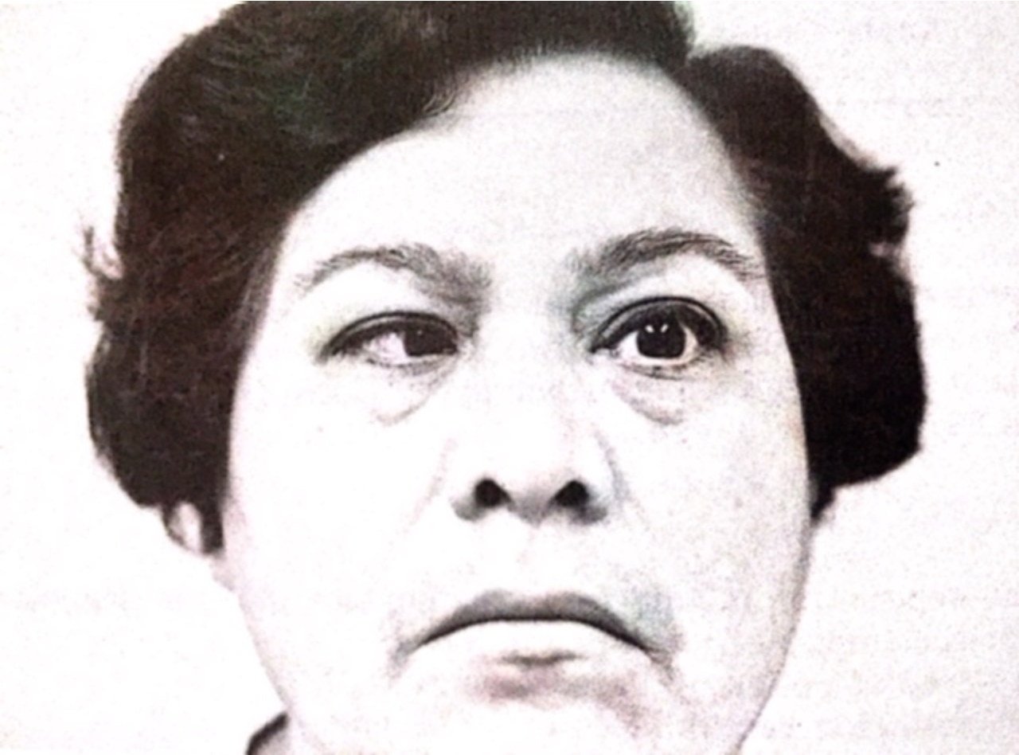

LABORATORY DATA
Complete blood count, VDRL, sedimentation rate, x-rays of chest and skull were all normal. The 2-hour postprandial sugar level was elevated. Intravenous injection of 10 mg of Tensilon did not alter the diplopia.

